**Experiment: 4**

PART A

(PART A: TO BE REFERRED BY STUDENTS)

**Aim:** **To study operators and expressions.**

**Learning Outcomes: Learner would be able to**

Interpret the scenario to decide on suitable data types, variables or constants and operator hierarchy.

**Task 1: Evaluate the following expression without using code blocks.**

|  |  |
| --- | --- |
| int i =9, j=6;  float x =0.5, y =0.1;  char a ='a', b ='b'; | |
| **Expression** | **Output (With Justification)** |
| 1. (3 * i – 2 * j) % (2 * a - b) |  |
| 1. (x>y) && (i>0) && (j>5) |  |
| 1. a==99 |  |
| 1. for a = 5 and b = 10   z = (a < b)? a+b : a - b |  |
| 1. i = 10;   i++;  a = i + 10; |  |
| 1. for i = 10, j = 5   z = (i + 10 < j)? 100:10 |  |
| 1. with a=1, b=2, c=12, d=2, e=5, f=2   a = b += c++ − d + −−e/−f; |  |
| 1. with x=12, y=7, z   z= x!=4 || y==2; |  |
| 1. with int i=-3, j=2, k=0, m   m = ++i || ++j && ++k; |  |

**Task 2:** Write a C++ program that accepts coordinates of two-dimensional points A and B and prints out (using two decimal places) the distance between A and B. It also prints out the coordinates (using two decimal places) of the midpoint of A and B.

**Test data and expected output:**

Enter coordinates of points A: (-1, 3)

Enter coordinates of points B: (2, -1)

Distance between A and B is 5.00

The coordinates of midpoint of A and B are (0.50,1.00)

**Task 3:** Write a program to find largest of three numbers using conditional operator

**Task 4:** Write a program to display size of data types like int, float, char, double

**Task 5: Find the output of following code snippets without running the code on codeblocks. Justify your answer**.

* 1. int main()

{

int d=14,m=7,y=4696,c=0,val;

val=(d+m+y+(y/4)+c)%7;

cout<<val;

return 0;

}

1. if(a<b)

if(b>c)

statement1;

else

statement2;

**statement 2 will be executed if?**

1. int main()

{

int x, y=25, z=25;

x=y==z;

cout<<x;

}

1. int main()

{

int a=20, b=30, c=40;

if(c>b>a)

cout<<”True”;

else

cout<<”False”;

return 0;

}

1. int main()

{

int a=10, b=4, res;

res=a++;

cout<<a<<res;

res=a--;

cout<<a<<res;

res=++a;

cout<<a<<res;

res=--a;

cout<<a<<res;

return 0;

}

1. int main()

{

int x=7, y=10;

if (x && y>20)

cout<<x;

else

cout<<y;

return 0;

}

**Theory:**

An operator in a programming language is a symbol that tells the compiler or interpreter to perform a specific mathematical, relational or logical operation and produce a final result.

|  |  |
| --- | --- |
| **Types of Operators** | **Description** |
| Arithmetic_operators | These are used to perform mathematical calculations like addition, subtraction, multiplication, division and modulus |
| [Assignment_operators](http://fresh2refresh.com/c/c-operators-expressions/c-assignment-operators/) | These are used to assign the values for the variables in C programs. |
| [Relational operators](http://fresh2refresh.com/c/c-operators-expressions/c-relational-operators/) | These operators are used to compare the value of two variables. |
| [Logical operators](http://fresh2refresh.com/c/c-operators-expressions/c-logical-operators/) | These operators are used to perform logical operations on the given two variables. |
| [Bit wise operators](http://fresh2refresh.com/c/c-operators-expressions/c-bit-wise-operators/) | These operators are used to perform bit operations on given two variables. |
| [Conditional (ternary) operators](http://fresh2refresh.com/c/c-operators-expressions/c-conditional-operators/) | Conditional operators return one value if condition is true and returns another value is condition is false. |
| [Increment/decrement operators](http://fresh2refresh.com/c/c-operators-expressions/c-increment-decrement-operators/) | These operators are used to either increase or decrease the value of the variable by one. |
| [Special operators](http://fresh2refresh.com/c/c-operators-expressions/c-special-operators/) | &, *, sizeof( ) and ternary operators. |

**Operator Precedence and Associativity:**

Operator precedence is used to determine the order of operators evaluated in an expression. In an expression the operator with higher precedence is evaluated first and the operator with least precedence is evaluated last.

Operator associativity is used to determine the order of operators with equal precedence evaluated in an expression. When an expression contains multiple operators with equal precedence, we use associativity to determine the order of evaluation of those operators.

An expression is evaluated based on the precedence and associativity of the operators in that expression.

Example: Evaluate the expression 10 + 4 * 3 / 2

In the above expression there are three operators **+, * and /**. Among these three operators, both multiplication and division have same higher precedence and addition has lower precedence. So, according to the operator precedence both multiplication and division are evaluated first and then addition is evaluated. As multiplication and division have same precedence they are evaluated based on the associativity. Here, the associativity of multiplication and division is **left to right**. So, multiplication is performed first, then division and finally addition. So, the above expression is evaluated in the order of **\* / and +**. It is evaluated as follows...

(10 + ((4 * 3) / 2))

4 * 3 ====> 12  
12 / 2 ===> 6  
10 + 6 ===> 16  
The expression is evaluated to **16**.

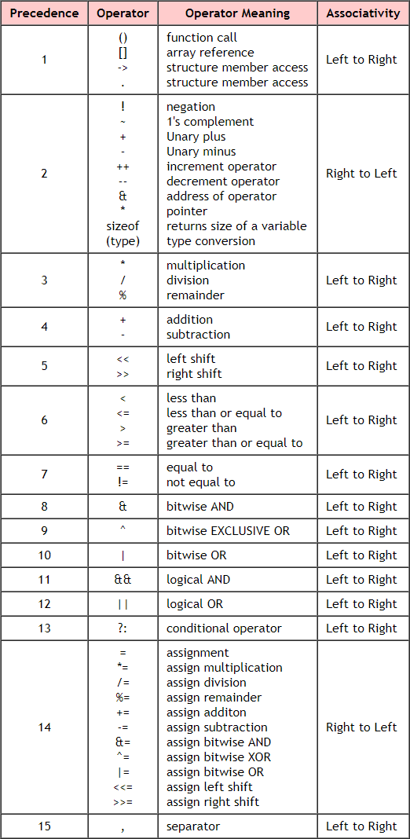

PART B

(PART B: TO BE COMPLETED BY STUDENTS)

Students must submit the soft copy as per following segments within two hours of the practical. The soft copy must be uploaded on the portal at the end of the practical. The filename should be **PPS_batch_rollno_experimentno Example: PPS_B2_B001_Exp1**

|  |  |
| --- | --- |
| **Roll No.:** | **Name:** |
| **Prog/Yr/Sem:** | **Batch:** |
| **Date of Experiment:** | **Date of Submission:** |

Task 1:

Task 2:

Task 3:

Task4:

Task 5:

**Conclusion (Learning Outcomes):** Reflect on the questions answered by you jot down your learnings about the Topic: Input/Output Statements, Operators, Expressions, Data Types, and Variables.

**Homework Questions:**

1. Two numbers are inputted through the keyboard. Write a program to perform various arithmetic operations (+,-,*, /, %).

2. A four digit number is inputted through the keyboard. Write a program to reverse the number.

3. Write a program to find the sum of a cube of three digit numbers. For example : number is 123 then Sum = 13 + 23+ 33